Q1

- **Long-term scheduling**: It determines which programs are admitted to the system for processing. It selects processes from the queue and loads them into memory for execution.

- **I/O scheduling**: It is responsible for deciding the order in which I/O requests are processed. The aim of I/O scheduling is to improve the performance of the system by reducing the average time it takes to complete an I/O request.

- **Short-term scheduling**: It is responsible for deciding which of the ready, in-memory processes is to be executed. The aim of processor scheduling is to assign processes to be executed by the processor or processors over time, in a way that meets system objectives, such as response time, throughput, and processor efficiency.

- **Medium-term scheduling**: It is responsible for deciding which processes should be swapped in or out of memory.

Q2

The analysis mechanism that defines the input for which the algorithm takes the least time (fastest time to complete) is **best case analysis**¹. It is used to determine the lower bound of an algorithm's running time. The best-case running time of an algorithm is the minimum amount of time it takes to solve a problem instance of size n³.

There are three types of analysis mechanisms for algorithms:

- **Worst-case analysis**: It calculates the upper bound on the running time of an algorithm. It is mostly used to determine the maximum amount of time an algorithm will take to solve a problem instance of size n¹.

- **Best-case analysis**: It calculates the lower bound on the running time of an algorithm. It is very rarely used¹.

- **Average-case analysis**: It calculates the expected running time of an algorithm when all possible inputs are equally likely¹.

Q3

The UML diagram that is not used to represent dynamic behavior of an object during analysis is **Instance diagram**. The other three diagrams are used to represent dynamic behavior of an object during analysis. Sequence diagrams are used to represent interactions between objects in a sequential order. Collaboration diagrams are used to represent interactions between objects in a non-sequential order. Activity diagrams are used to represent the flow of activities and actions within a system¹²³.

Q5

Ensemble methods* are techniques that combine the decisions from several base machine learning (ML) models to find a predictive model to achieve optimum results.

The main principle of ensemble methods is to combine weak and strong learners to form strong and versatile learners.

This guide will introduce you to the two main methods of ensemble learning: bagging and boosting. Bagging is a parallel ensemble, while boosting is sequential.

Lasso is not a type of ensemble learning. Ensemble learning is a method of combining the predictions of two or more models to achieve better performance than any individual model. It requires creating diverse models and deciding how to fuse their salient properties. Ensemble learning may be more efficient at reducing error sources like noise, variance, and bias than increasing resources for a single model¹.

Notice that the decision tree contains several if-else statements in a strict order, making the model inflexible. It gives rise to overfitting, which occurs when a function fits the data too well. That means the model will be accurate only on the data it's been trained on. The model fails to work if there is a slight change in the training data or new data.

Using one decision tree is can be problematic and might not be stable enough; however, using multiple decision trees and combining their results will do great. Combining multiple classifiers in a prediction model is called ensembling. The simple rule of ensemble methods is to reduce the error by reducing the variance.

**Ensemble Techniques**

### Bagging

The term "bagging" comes from the words **B**ootstrap **Agg**regator.

The bootstrap method refers to creating small multiple subsets of data from an entire dataset. These subsets of data are randomly sampled and replaced. The replacement of the sample is known as resampling.

Next, bagging combines the results of all the learners and adds (aggregates) their prediction by averaging (mean) their outputs to get to final results.

The Random Forest (RF) algorithm can solve the problem of overfitting in decision trees. Random orest is the ensemble of the decision trees. It builds a forest of many random decision trees.

The process of RF and Bagging is almost the same. RF selects only the best features from the subset to split the node.

### Boosting

The boosting technique follows a sequential order. The output of one base learner will be input to another. If a base classifier is misclassified (red box), its weight will get increased (over-weighting) and the next base learner will classify more correctly.

The next logical step is to combine the classifiers to predict the results.

Gradient Descent Boosting, AdaBoost, and XGbooost are some extensions over boosting methods.

Gradient boosting minimizes the loss but adds gradient optimization in the iteration, whereas **Ada**ptive **Boost**ing, or AdaBoost, tweaks the instance of weights for every new predictor.

Boosting—or any other ensemble method, for that matter—will reduce the likelihood of overfitting of the model.

Q6

The answer is **a. Automatic programming**. Automatic programming is a type of computer programming in which some mechanism generates a computer program to allow human programmers to write the code at a higher abstraction level. I hope this helps!

Q7

The answer is **b. Opacity**. The CSS property used to specify the transparency of an element is opacity. I hope this helps!

Q8

The data link layer can further be divided in to two layers: the upper sub-layer

that is responsible for flow and error control is called the logical link control (LLC)

layer; the lower sub-layer that is mostly responsible for multiple access resolution

is called the media access control (MAC) layerQ8

The answer is **d. It is process to process interaction**. The functionalities of the application layer include process to process communication. I hope this helps!

Q12

Here are the referential triggered actions:

- **ON DELETE CASCADE**: Deletes all the referencing tuples when the referenced tuple is deleted.

- **ON UPDATE CASCADE**: Changes the value of the referencing foreign key attribute to the updated primary key value for all the referencing tuples when the referenced tuple is updated.

- **ON DELETE SET NULL**: Sets the referencing foreign key attribute to NULL when the referenced tuple is deleted.

- **ON UPDATE SET NULL**: Sets the referencing foreign key attribute to NULL when the referenced tuple is updated.

- **ON DELETE SET DEFAULT**: Sets the referencing foreign key attribute to its default value when the referenced tuple is deleted.

- **ON UPDATE SET DEFAULT**: Sets the referencing foreign key attribute to its default value when the referenced tuple is updated.

Yes, there are other referential triggered actions. Here are some more:

- **ON DELETE RESTRICT**: Prevents the deletion of the referenced tuple if there are referencing tuples.

- **ON UPDATE RESTRICT**: Prevents the update of the referenced tuple if there are referencing tuples.

- **ON DELETE NO ACTION**: Prevents the deletion of the referenced tuple if there are referencing tuples.

- **ON UPDATE NO ACTION**: Prevents the update of the referenced tuple if there are referencing tuples.

the difference between ON DELETE RESTRICT and ON DELETE NO ACTION.

ON DELETE RESTRICT prevents the deletion of the referenced tuple if there are referencing tuples.

ON DELETE NO ACTION also prevents the deletion of the referenced tuple if there are referencing tuples. The difference is that ON DELETE NO ACTION is not supported by some database management systems.

Q13

The file system that can be used to change certain kernel parameters at runtime using sysctl command is **Procfs** .

Q14

A software tool, such as a design editor or a program debugger, that developers and other software stakeholders use to support an activity in the software development process is called **CASE tools**.

Here are the definitions of the other options:

- **CMMI**: Capability Maturity Model Integration (CMMI) is a process improvement approach that provides organizations with the essential elements of effective processes.

- **CMM**: Capability Maturity Model (CMM) is a process improvement approach that provides organizations with the essential elements of effective processes.

- **BPMN**: Business Process Model and Notation (BPMN) is a graphical representation for specifying business processes in a business process model.

Q15

The statement that designates part of the process of how a switch resolves to forward a frame destined for a recognized unicast MAC address is **a. It matches the unicast destination address to the bridging, or MAC address, table**.

Q17

gi. c. HTML form elements are used for displaying outputsQ18

types of organizational structures: ¹.:

- Hierarchical org structure

- Functional org structure

- Horizontal or flat org structure

- Divisional org structures (market-based, product-based, geographic)

- Matrix org structure

- Team-based org structure

- Network org structure

Q22

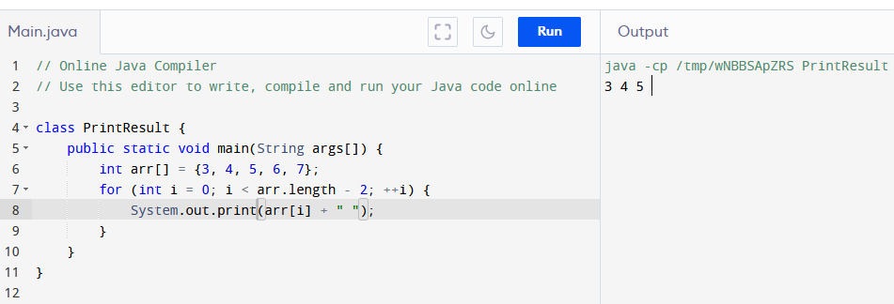 Q23

An Artificial Intelligence system is composed of an agent and an environment.

Q24

Regarding integration testing, the correct answer is c. It proves the functioning of different software components when integrated together.

Q25

The leading agile development method is Scrum.

Q26

PROTECTED

Q27

The data link layer is the second layer of the OSI model and is responsible for providing reliable data transfer across a physical link.

To answer your question, the correct answer is a. OSPF.

Q38

The purpose of the <iostream> header file in C++ program is to provide input/output functionality.

To answer your question, the correct answer is c. to provide input/output functionality.

Q29

Informed search algorithms are those that use problem-specific knowledge beyond the definition of the problem itself to guide their search.

To answer your question, the correct answer is b. They are admissible.

Q47

The technique that allows large numbers of ideas to be classified into groups for review and analysis is called Affinity Diagrams¹.

Q59

The **bootstrap** program initializes all aspects of the system, from cpu registers to device controllers and the contents of main memory, and then starts the operating system.

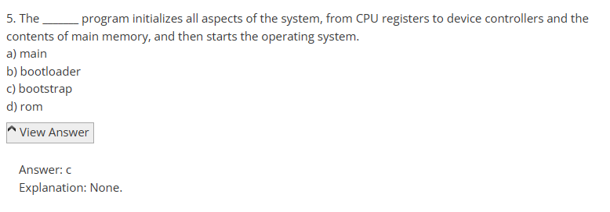

Q61

a. Code Auditor

A code auditor is a tool used to check the quality of software code and ensure that it meets certain coding standards or guidelines. It analyzes the source code and identifies potential issues, violations, or deviations from the defined coding standards.

Code auditors typically perform static code analysis, examining the code without executing it. They can check for various aspects, such as code complexity, adherence to naming conventions, proper use of data types, error handling practices, security vulnerabilities, and other coding best practices.

The purpose of a code auditor is to improve the maintainability, readability, and overall quality of the software code. It helps identify and rectify potential issues early in the development process, reducing the chances of bugs and enhancing the software's overall reliability.

**Q67**

**APK** stands for **Android Package Kit**.

Q93

The data link sub layer which is responsible for identifying Network layer protocols and then encapsulating them is known as **Logical Link Control (LLC)**.